In case custmer’s programmer can’t read any types of key chips like key ID46, 47, 48,49, AES and 5C ect. Ask client to go to programmer menu as shown follows and provide the programmer version information and device series number.
First of all, make sure that you have not connected the programmer to the vehicle OBD connector.
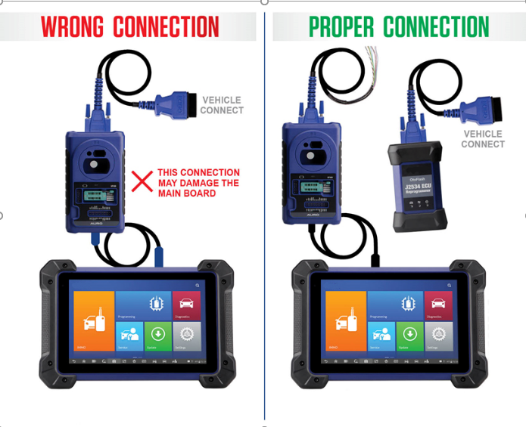
Then check if you use the right USB cable to connect the device to the programmer.

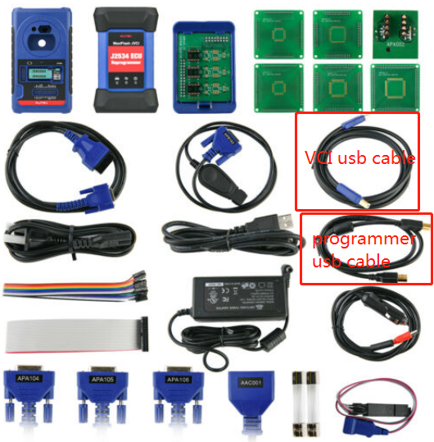
Then go to programmer menu to check the programmer function.
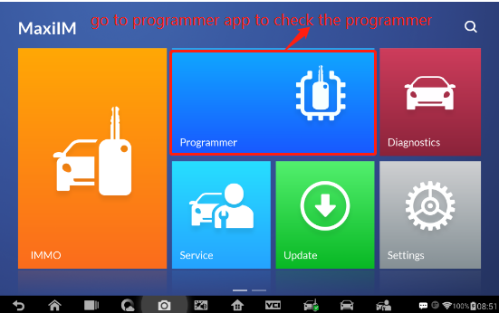
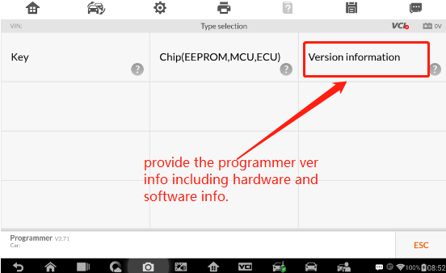

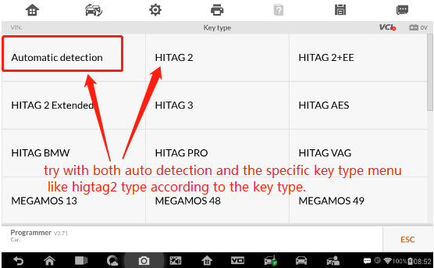
Also you can go to Autel official website to download PC version programmer V2.61 software.
The specific procedure you can refer to the followings.
http://blog.obdii365.com/2019/08/12/autel-xp400-adapter-user-manual/
Where-to-download-autel-xp400-software
http://blog.obdii365.com/2020/07/23/where-to-download-autel-xp400-software/
Notes: The programmer software applies to XP200, XP400 and XP400Pro.
The software will auto adjust for the programmer.
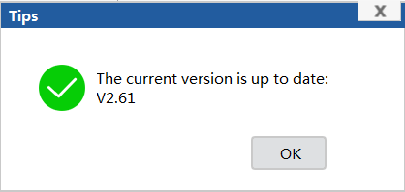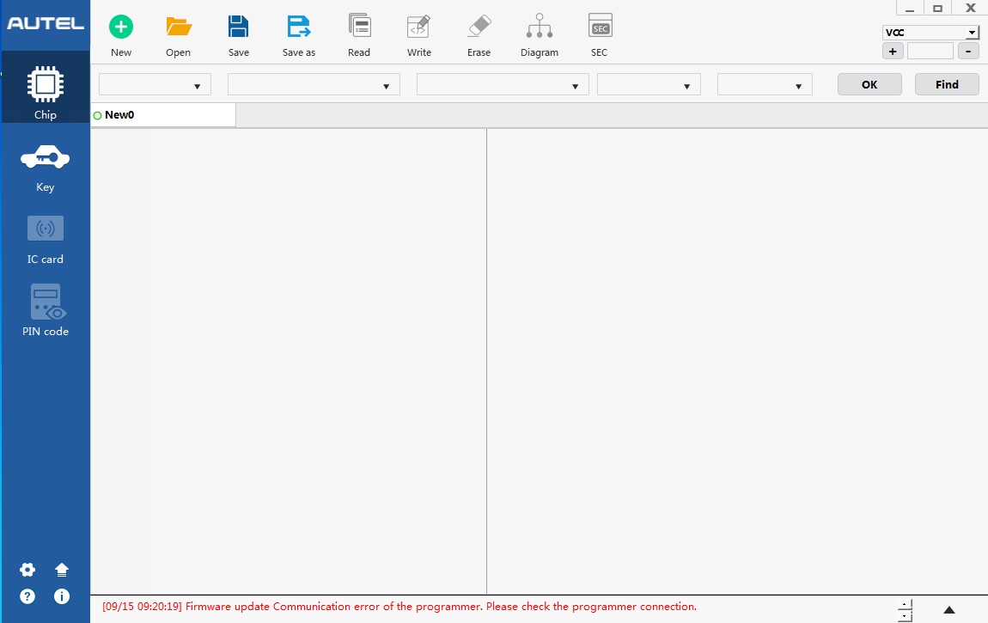
If programmer connection can’t detect any keys both with PC end and tablet.
Please describe how the programmer stop work after what operation? And it needs to return to the factory to repair if all of above methods tried and not working.

