To check whether the key programming function or IMMO part replacement function is supported or not, you can go to function viewer APP to check whether it is supported or not.
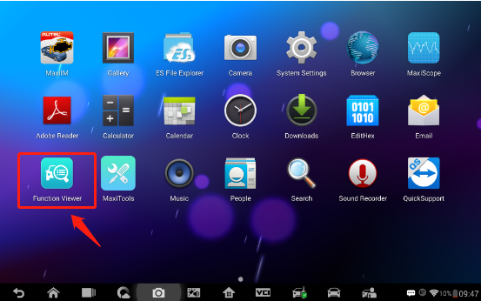
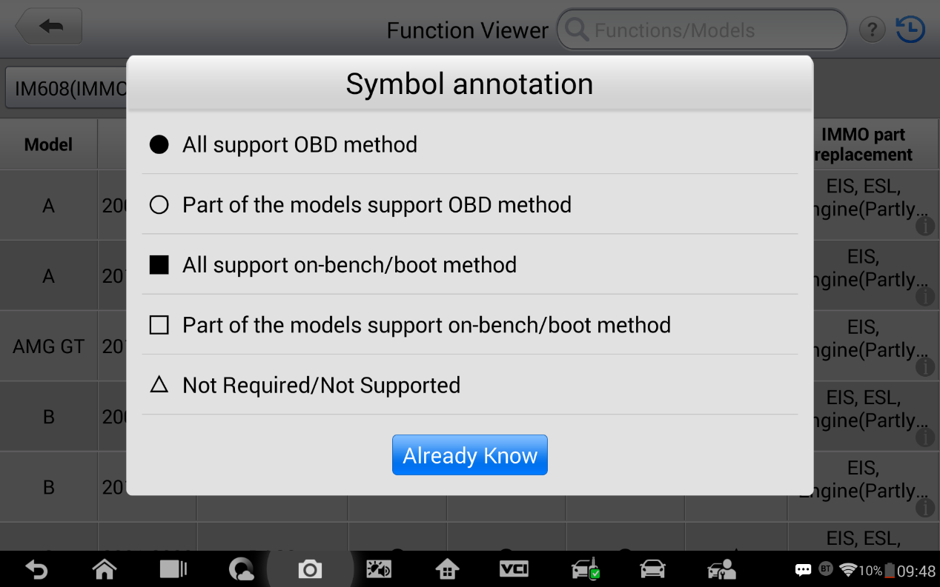
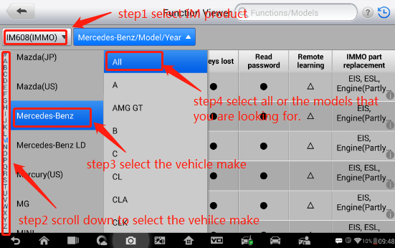
If you are not sure what triangle and solid circle means, you can click on the question mark on the top right corner to get what it means.

