How to use J2534 ECU programmer with OE software

You download the PC suite from Autel website, then run the PC suite app on your desk top.
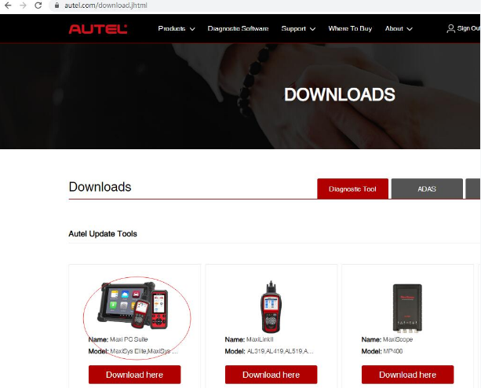
Connect your device to the computer through USB.
​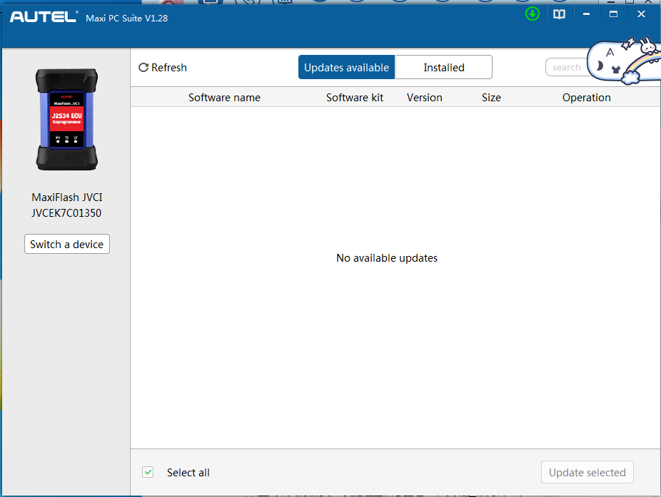​During the process, select the following
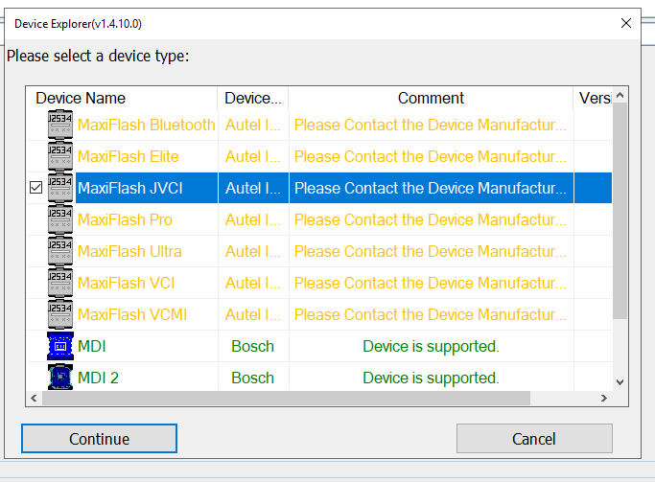
Then you use it with the OE software.

