To remotely connect to the Autel tablet device, here we use Autel IM608 as a demo to show the procedure.
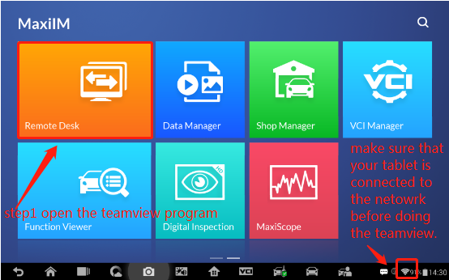
After entering the software, stay in the below page until the end.
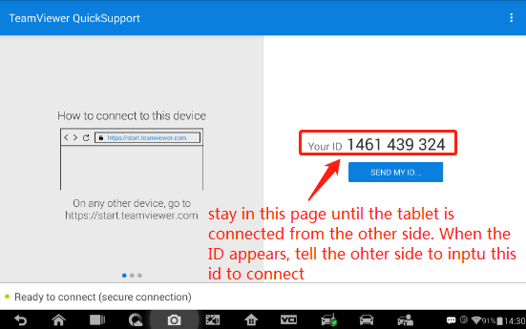
Page from the other side (PC end)to connect your tablet shown as below.
